Case Study: How Does a Bike-Share Navigate Speedy Success?
This case study demonstrates an end-to-end data analysis workflow using Cyclistic bike-share data.

1. Business Task
Cyclistic aims to increase profitability by converting casual riders into annual members.
This analysis focuses on identifying key behavioral differences between casual riders and annual members using historical trip data.
The insights generated will support targeted marketing strategies designed to increase membership conversions.
Key Metrics
- Total Rides: 5.5M+
- Members: 64%
- Casual Riders: 36%

- Avg Ride Duration:
  - Members: ~12 min
  - Casual: ~19 min

2. Key Business Question
The primary question guiding this analysis is:
How do annual members and casual riders use Cyclistic bikes differently?

3. Stakeholders
- Cyclistic marketing team (responsible for campaign strategy)
- Cyclistic executive team (decision-makers approving recommendations)

4. Context of Additional Questions
Additional business questions include:
- Why casual riders might consider purchasing memberships
- How digital media can influence conversions
While these are important, this analysis focuses primarily on behavioral differences to support those decisions.

5. Data Source and Preparation
The dataset used for this analysis consists of 12 months of Cyclistic trip data (January 2025 to December 2025).
The data was sourced from Divvy’s public trip dataset repository.

Data Ingestion Process
Due to file size constraints, a hybrid ingestion approach was used:
- Smaller CSV files were directly uploaded into Google BigQuery
- Larger files (>100MB) were first stored in Google Cloud Storage and then loaded into BigQuery
All datasets were structured into separate tables and validated for schema consistency before analysis.

6. Data Processing

6.1 Combining Data
The 12 monthly datasets were combined into a single table using UNION ALL to create a unified dataset:
- Final combined table: all_trips_2025
This step ensured that all trip records could be analyzed collectively.

6.2 Feature Engineering
New variables were created to support analysis:
- ride_length_seconds:
Calculated using the difference between trip end and start times
- day_of_week:
Extracted from the trip start timestamp to analyze weekly usage patterns
This resulted in a new table:
- cleaned_trips

6.3 Data Cleaning
To ensure data quality and reliability, the dataset was filtered using the following criteria:
- Removed rides with invalid durations (≤ 0 seconds or ≥ 24 hours)
- Removed records with missing start or end timestamps
- Retained only valid user types (member, casual)
- Validated geographic coordinates by ensuring latitude values were within -90 to 90 and longitude values within -180 to 180 to remove invalid location data.

This resulted in the final dataset:
- final_trips

6.4 Data Quality Summary
- Initial records: 5,552,994
- Final records after cleaning: 5,545,413
- Records removed: 7,581 (~0.14%)
This indicates that the dataset was largely clean, with only a small proportion of invalid or inconsistent records removed.

6.5 Analysis Approach
The analysis was conducted using SQL in Google BigQuery to aggregate and transform the data. Key metrics such as total rides, average ride duration, and ride distribution by day of the week were calculated to identify behavioral patterns.
The processed dataset was then visualized in Tableau to uncover trends and communicate insights effectively. Visualizations were designed to compare usage patterns between casual riders and members across different dimensions, including frequency, duration, and time of usage.

7. Data Analysis

7.1 Overall Usage Comparison
The analysis revealed a clear difference in usage patterns between annual members and casual riders.
- Members: 3,551,516 rides (64.04%)
- Casual riders: 1,993,897 rides (35.96%)
Additionally, average ride duration differed significantly:
- Members: 11.94 minutes
- Casual riders: 19.10 minutes

Key Insight:
Annual members take more frequent but shorter trips, while casual riders take fewer but longer trips.
This indicates that:
- Annual members rely on the service for consistent, routine-based travel such as commuting.
- Casual riders are more likely to use the service for occasional, leisure-oriented activities.
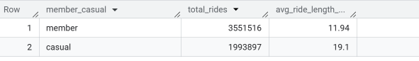

7.2 Ride Distribution by Day of Week
Ride patterns across the week show distinct behavioral differences.

Casual Riders
- Highest usage on:
  - Saturday (~412k rides)
  - Sunday (~330k rides)
- Lowest usage during weekdays

Members
- Highest usage on:
  - Thursday (~575k rides)
  - Tuesday (~562k rides)
  - Wednesday (~549k rides)
- More consistent weekday usage
- Slight drop on weekends

Key Insight:
- Casual riders are weekend-focused users
- Members are weekday-focused users
This reinforces the idea that:
- Casual riders engage in leisure activities
- Members rely on bikes for regular commuting
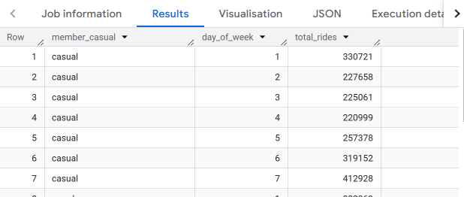
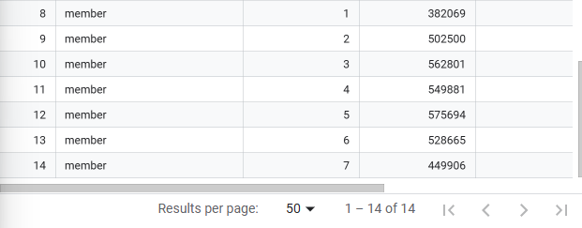

7.3 Average Ride Length by Day of Week
Further analysis of ride duration across the week shows additional behavioral patterns.

Casual Riders
- Longest rides on:
  - Sunday (~22.11 minutes)
  - Saturday (~21.38 minutes)
- Shorter rides during weekdays (~15–17 minutes)

Members
- Consistent ride duration across all days:
  - ~11–13 minutes
- Minimal variation between weekdays and weekends

Key Insight:
- Casual riders take longer rides on weekends, indicating recreational usage
- Members maintain consistent ride durations, suggesting structured, routine trips
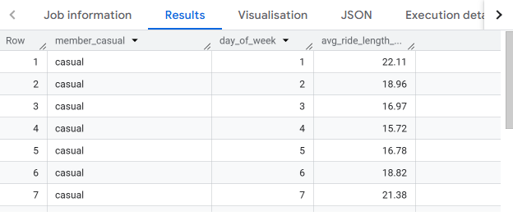
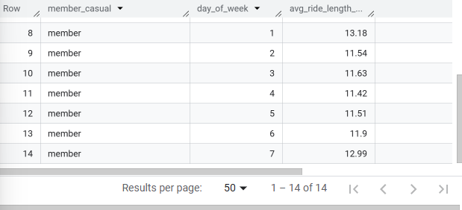

7.4 Summary of Key Behavioral Differences
Behavior | Casual Riders | Members
Ride Frequency | Lower | Higher
Ride Duration | Longer | Shorter
Peak Usage | Weekends | Weekdays
Usage Type | Leisure / recreational | Commuting / routine

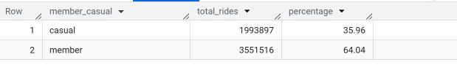

8. Data Visualization (Tableau)

The processed dataset was visualized using Tableau to identify patterns and communicate insights effectively. A dashboard was created to compare behavioral differences between casual riders and annual members.
The dashboard includes the following visualizations:
- Total Rides by User Type
Compares overall usage between casual riders and members, highlighting that members account for a larger share of total rides.

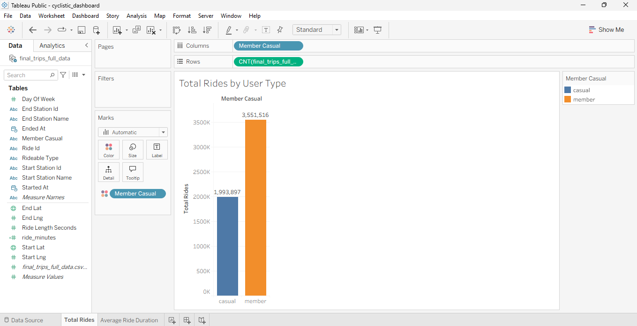
- Average Ride Duration by User Type
Shows that casual riders take significantly longer rides compared to members.

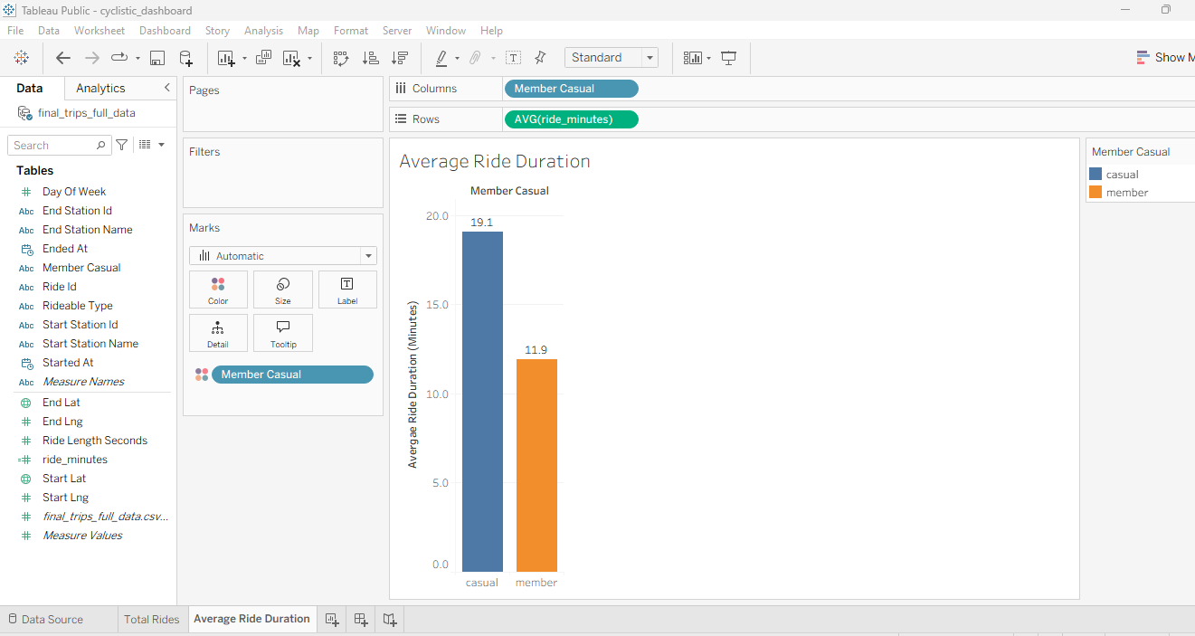
- Ride Distribution by Day of Week
Illustrates that casual riders are more active on weekends, while members show consistent usage throughout weekdays.

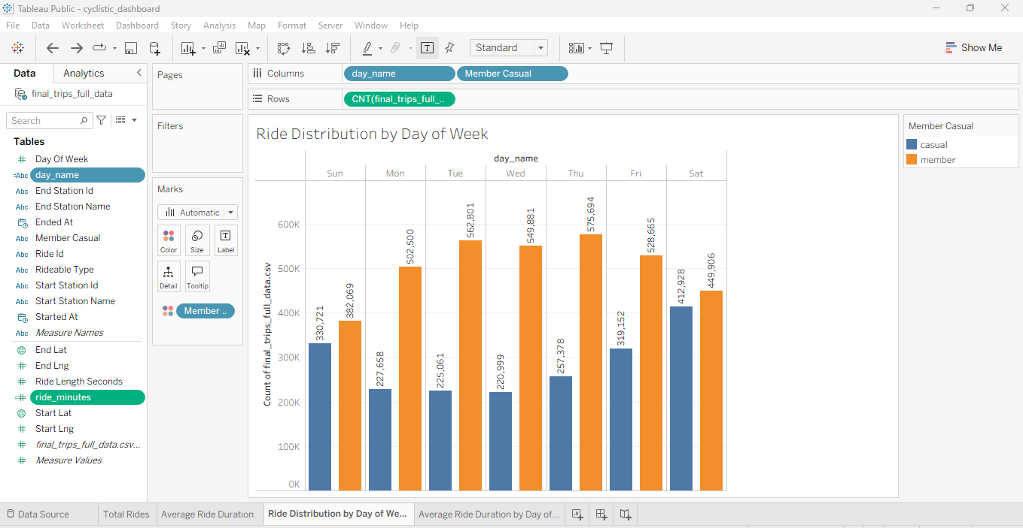
- Average Ride Duration by Day of Week
Highlights that casual riders take longer rides on weekends, while members maintain consistent ride durations across all days.

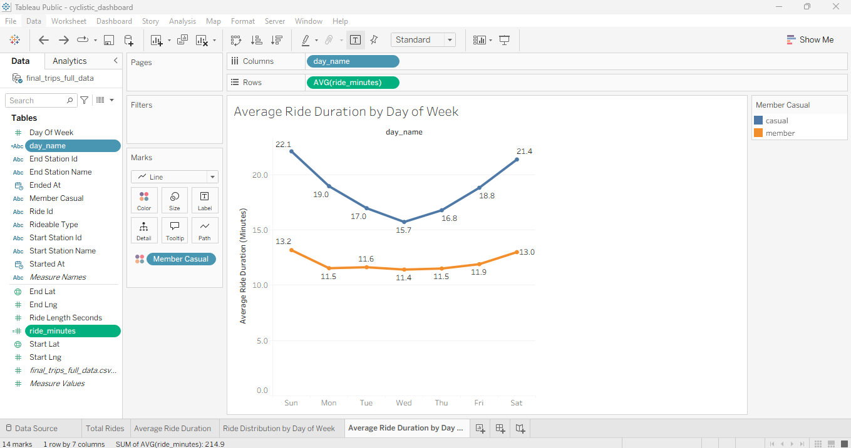
The dashboard was designed with consistent color coding and layout to ensure clarity and ease of interpretation. This enables stakeholders to quickly understand key trends and make informed decisions.

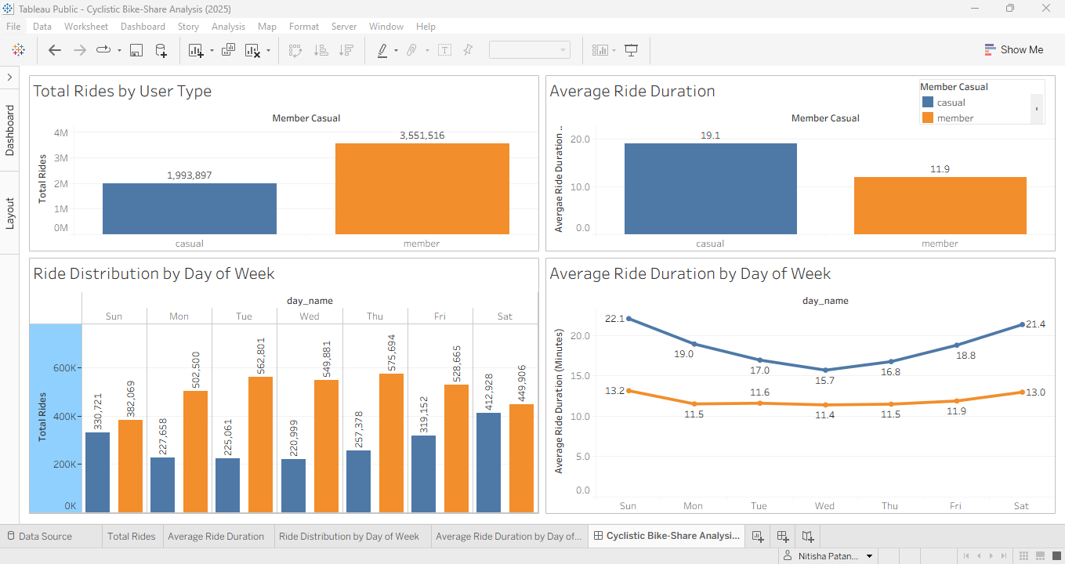

Tableau Dashboard:

View Interactive Dashboard (Tableau Public)

Cyclistic Bike-Share Analysis (2025).twb

https://public.tableau.com/views/cyclistic_dashboard_17757828279210/CyclisticBike-ShareAnalysis2025?:language=en-US&:sid=&:redirect=auth&:display_count=n&:origin=viz_share_link
The dashboard provides an interactive view for stakeholders to explore usage patterns dynamically.

9. Recommendations
Based on the analysis of rider behavior, several data-driven strategies can be implemented to convert casual riders into annual members.

Recommendation 1: Target Casual Riders During Peak Weekend Usage
The analysis showed that casual riders predominantly use bikes on weekends, with the highest activity on Saturdays and Sundays. This indicates that casual usage is largely recreational.
Cyclistic should implement weekend-focused marketing campaigns, such as:
- Limited-time membership discounts during weekends
- In-app prompts after ride completion
- Weekend promotional bundles
Targeting users during peak engagement periods increases the likelihood of conversion.

Recommendation 2: Highlight Cost Benefits of Membership
Casual riders have significantly longer average ride durations compared to members, suggesting higher per-ride costs.
Cyclistic should emphasize the cost-saving advantages of membership, including:
- Comparisons showing how frequent rides can offset membership costs
- Personalized ride summaries highlighting potential savings
- Clear messaging such as “Save more with unlimited rides”
This approach can help casual riders better recognize the financial advantages of transitioning to a membership plan.

Recommendation 3: Encourage Habit Formation Through Trial and Incentives
Members exhibit consistent weekday usage, indicating habitual and routine-based behavior. In contrast, casual riders use the service sporadically.
Cyclistic can encourage habit formation by:
- Offering short-term trial memberships (e.g., weekly passes)
- Providing incentives for weekday rides
- Introducing reward systems such as ride streaks or loyalty points
These strategies can help transition casual riders into regular users.

Recommendation 4: Use Lifestyle-Based Marketing for Leisure Riders
Casual riders are more likely to use bikes for leisure, tourism, or recreational purposes, as indicated by longer ride durations and weekend usage patterns.
Cyclistic should adopt lifestyle-oriented marketing strategies, such as:
- Promoting city exploration and recreational riding experiences
- Highlighting flexibility and convenience of membership
- Creating campaigns centered around leisure activities and experiences
This approach aligns marketing messages with the motivations of casual riders.

10. Conclusion
The analysis revealed clear behavioral differences between casual riders and annual members. Members demonstrate consistent, high-frequency usage with shorter ride durations, indicating routine commuting behavior. In contrast, casual riders exhibit lower frequency but significantly longer ride durations, with peak usage occurring on weekends, suggesting recreational usage patterns.
These insights highlight a key opportunity for Cyclistic to convert casual riders into members by aligning marketing strategies with their usage behavior. By targeting casual riders during peak engagement periods, emphasizing cost benefits, and encouraging habitual usage, Cyclistic can increase membership adoption and overall profitability.
The combination of data-driven insights and targeted recommendations provides a strong foundation for strategic decision-making.

11. Tools Used
- Google BigQuery:
Used for data storage, transformation, and SQL-based analysis.
- Google Cloud Storage:
Used for handling large dataset uploads before loading into BigQuery.
- SQL:
Used for data cleaning, aggregation, and feature engineering.
- Tableau:
Used for data visualization and dashboard creation to present insights effectively.

